**One Verse Evangelism**

**Name: ___________________________________________**

1. One verse evangelism presents some basics about the Christian gospel. It is very brief and does not communicate the entire gospel, or all of the good news, but it does show several key ideas related to receiving salvation in Jesus Christ.
2. All leaders need to be able to articulate and share the gospel verbally with their friends.
3. This outline is a tool for a conversation and to learn what the other person thinks. It is rarely going to “convince” or “convert” someone, though it could. Expect to use it to open the door to have a conversation about Jesus Christ.

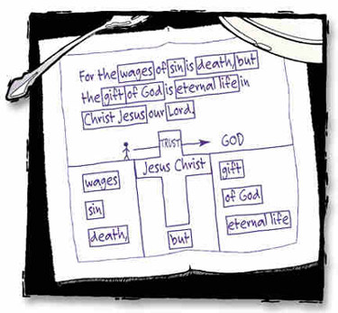**How-To Present One-Verse Evangelism**

1. Introduce the idea
   1. For this homework, tell the person you are in training and need to do this homework assignment. Moving forward, you could say, “There are a lot of questions about God, can I share with you what the Bible says about life?”
   2. Write out the verse word-for-word. Ideally have them read it aloud from a Bible while you write.
2. Find the words
   1. Then, ask them to identify the main words, starting from the beginning (first one is “wages”)
   2. Then write the word down and make a box around it per the image below.
   3. Then ask them, “How would you explain/define/describe: ________ (a wage)?”
   4. Then ask them to find the next word, and repeat.
3. Transitions and ending
   1. After you complete WAGES-SIN-DEATH, summarize this message and let them know God sees this dilemma and has done something about it!
   2. After you complete GIFT-GOD-ETERNAL LIFE, summarize the offer of the free gift of God, tell them this is only available because of Jesus Christ dying on the cross (draw the cross).
   3. Then, and *this is important*, tell them that every person starts “here” (on the left side), and that God does not force this gift on anyone, we must decide how to respond. Then, “Where do you see yourself?” And circle the left side and the right side of the drawing. At this point it is normal for there to be several moments of silence since it is a big question to ask.

Present this with two people, an easy person, and someone else who will not be as easy.

1. _____________________________________________
2. _____________________________________________