Digital Club Cards Automatically in Leader’s Phones
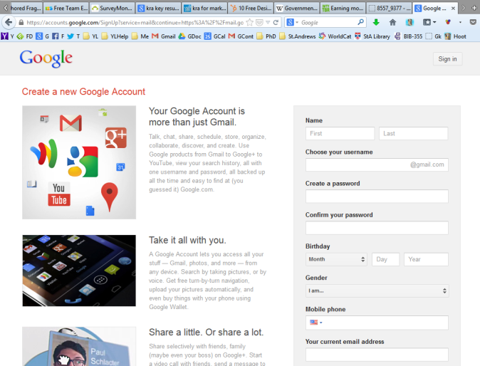
A Step by Step Guide from YLHelp
Step 1 - Make a New Gmail Account
-Go to gmail.com and make a new account.
-Make sure to write down the new email address and the password in a separate file. I recommend a Word file, but then also transfer it to a note in your cell phone.

Step 2 - Make a Wufoo Form
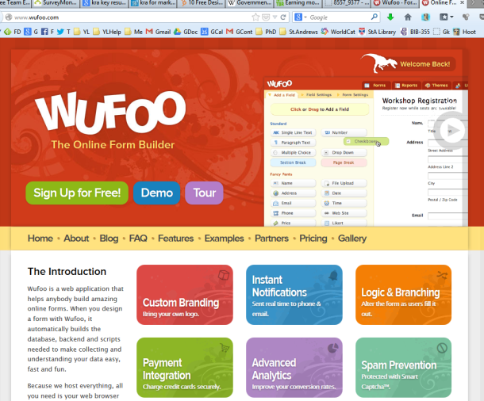
-Go to Wufoo.com and create an account.
-Be sure to write down the account information in the same file you created above.
-Then create a “New Form”.
-Create a form (see below), we use the following form information, you can choose whatever you like, but I’d recommend you keep it brief as the longer you make it, the less likely people are to fill it out.
- First Name
- Last Name
- Phone Number
- Year in School
- In the “Form Settings” field we use the following info:
- Form Name: “HHSYL Info”
- Confirmation Options: “Great! Thanks for coming to HHS YL! Check us out: Twitter: @horizonyl”

Wufoo Form Info...
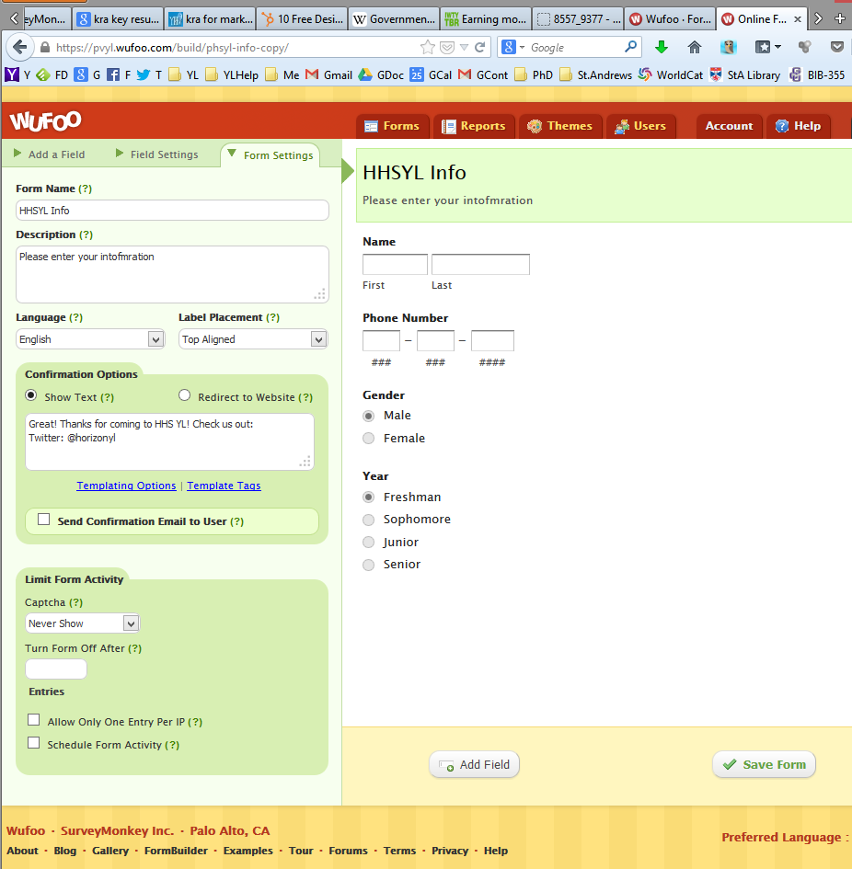
Then you are done with Wufoo!

Step 3 - Create the API link between Wufoo and Gmail through Zapier.com
-Create a free account with Zapier.com, again make sure to write down your account information.
-Then create a link between your Wufoo form and Google Contacts...
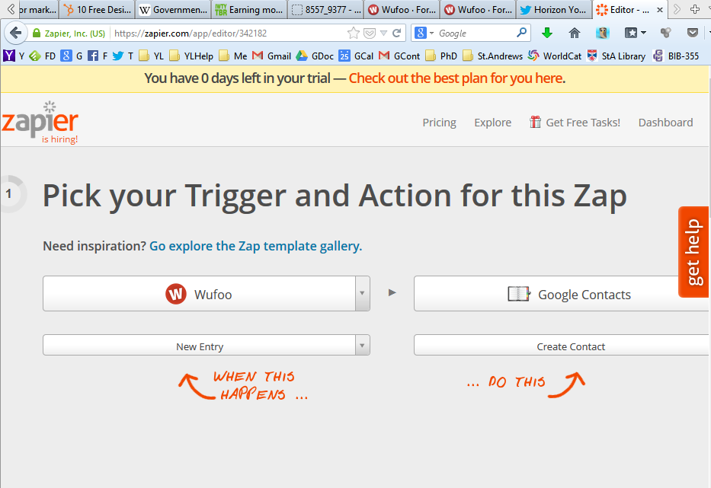

-After you have linked the accounts, then set up how the information will update. We add a prefix before the name, so if it is Susie Jones, we have it add a contact named YL-F13 Susie Jones, which lets us quickly see YL contacts and also tells us she added her info in the Fall of 2013.
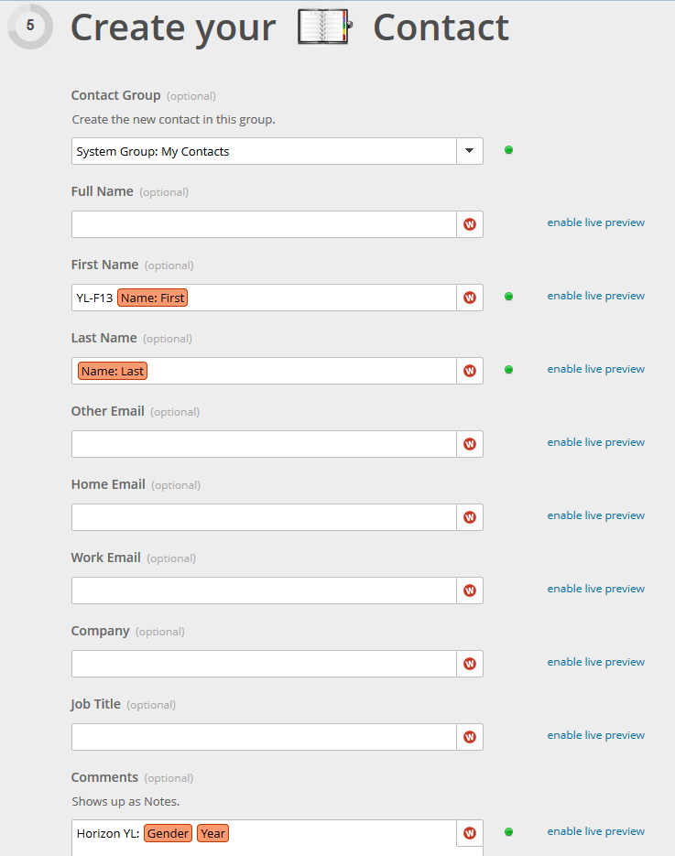
-Be sure to use the test features and when all set, click, “make this Zap live!”
-When this happens, every time a form is uploaded, then the Gmail account will automatically have the new contact information.

Step 4 - Share the Gmail account info with your YL team
Here is the info I send to leaders (we all have iPhones):
1. Go to "settings"
2. Go to "mail, contacts, calendar..."
3. Go to "add account"
4. Go to "other"
5. Go to "add CardDAV account"
6. Info...

Server: google.com
User name: [YOUR USER NAME]
Password: [YOUR PASSWORD]
Description: (you choose) ex: HHSYL Contacts

Then in contacts in the upper left you should see "groups" and there you can select all or only one of the groups you want to view.
Step 5 - [Optional] Create a text group which will send a link to the club card
-Create an account on cel.ly
-Create a new “Cell”
-In the welcome message say something like this...
Thx for joining the hhsyl group! Click here for the drawing https://pvyl.wufoo.com/forms/hhsyl-info/
-Give kids the opportunity to join during club by putting the number on the screen, when they join, you will now have a text group you can message about club and then they can fill out the link to add their info to the Google contacts group you set up above.
