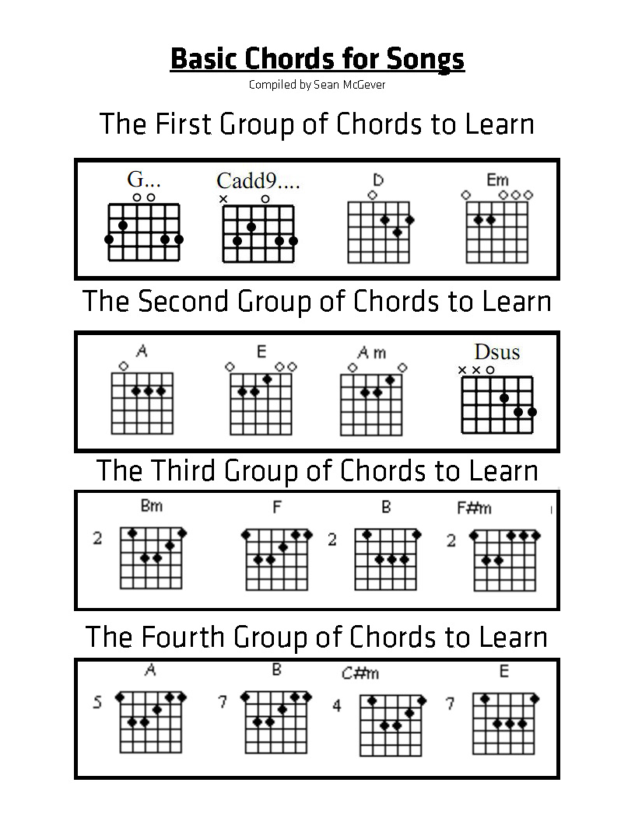*The following songs are simplified a bit for the first group of chords. When you see “C”, play the “Cadd9” chord above. When you see lyrics and not chords, just repeat the same rhythm from the previous section. It also helps to play along to a recording, just look up the song on Youtube.
Brown Eyed Girl

G C G D
Hey where did we go, days when the rains came
G C G D
Down in the hollow, playin' a new game
G C G D
Laughing and a running, hey, hey, skipping and a jumping
G C G D C
In the misty morning fog with our hearts a thumpin' and you
D G Em
My brown eyed girl
C D G
You my brown eyed girl
Whatever happened to Tuesday and so slow
Going down the old mine with a transistor radio
Standing in the sunlight laughing, hiding behind a rainbow's wall,
Slipping and sliding all along the water fall, with you
My brown eyed girl. You my brown eyed girl

D
Do you remember when we used to sing
G C G D
Sha la la la la la la la la la la te da
So hard to find my way, now that I'm on my own
I saw you just the other day, my how you have grown
Cast my memory back there, Lord, sometime I'm overcome thinking 'bout
Slipping and a sliding behind the stadium with you
My brown eyed girl. You my brown eyed girl

Sweet Home Alabama

D C G
Big wheels keep on turnin'
D C G
Carry me home to see my kin
D C G
Singing songs about the south land
D C G
I miss ole' ‘bama once again

Sweet home Alabama
Where the skies are so blue
Sweet home Alabama
Lord, I'm coming home to you

I heard Mr. Young sing about us
Well I heard ole' Neil put us down
Well I hope Neil Young will remember
A southern man don't need him around anyhow

Chorus
F C D (Don’t worry if you can’t play F)
In Birmingham they love the Gov'ner
We all did what we could do
Now Watergate does not bother me
Does your conscience bother you
Now tell the truth

Chorus
Now how about you.

Chorus

Amazing Love

D G A
I’m forgiven, because You were forsaken
D G A
I’m accepted, You were condemned
D G A
I’m alive and well, Your Spirit is within me
G A D
Because you died and rose again

D G
Amazing love, how can it be
D A
That You my king would die for me?
D G
Amazing love, I know it’s true
D A
And it’s my joy to honor You
G A D
In all I do I honor You

Lean On Me

G C G D
Sometimes in our lives, we all have pain, we all have sorrows.
G C G D-G
But, if we are wise, we know that there's always tomorrow.

G C G
Lean on me, when you're not strong, and I'll be your friend,
D
I'll help you carry on.
G C G
For, it won't be long, 'til I'm gonna need
D-G
Somebody to lean on.

Please swallow your pride, if I have things you need to borrow.
For, no one can fill, those of your needs, that you won't let show.

Chorus
G…
Just call on me brother, when you need a hand.
We all need somebody to lean on.
I just might have a problem that you'll understand.
We all need somebody to lean on.

Chorus (x2)

