Contact Work Encouragement Tech Guide
YLHelp - Sean McGever

This guide shows the steps needed to create a system in which leaders can log their contact work and then an update will go out to everyone on their team via text message.

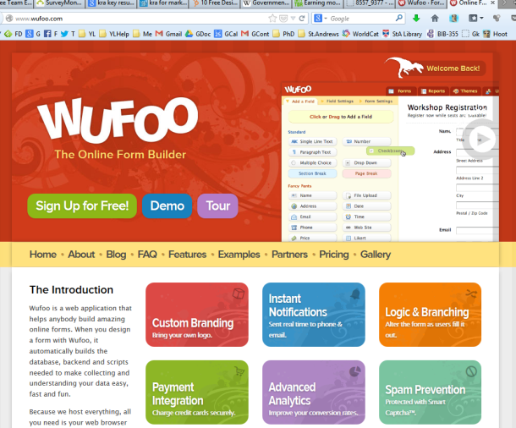
Step 1 - Create a Wufoo Form
-Go to Wufoo.com and create an account.
-Be sure to write down the account information in the same file you created above.
-Then create a “New Form”.
-Our form includes the following:

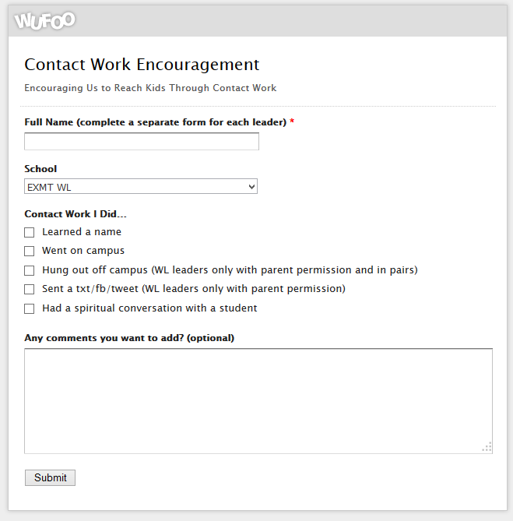
- Full Name (complete a separate form for each leader)
- School (use a dropdown option, this will be important for later steps)
- Contact Work I Did...
  - Learned a name
  - Went on campus
  - Hung out off campus (WL leaders only with parent permission and in pairs)
  - Sent a txt/fb/tweet (WL leaders only with parent permission)
  - Had a spiritual conversation with a student
- Any comments you want to add? (optional)

Step 2 - Create a Twitter (only as a tool, there is no need to promote this)
The purpose for this Twitter account is only as a tool to link Wufoo and Celly as you will see below. So the name of this account does not matter, and it will not need any “followers” or anything like that.
-Go to Twitter.com
-Create an account and be sure to write down the username and password
Step 3 - Create a Notification from Wufoo to Twitter
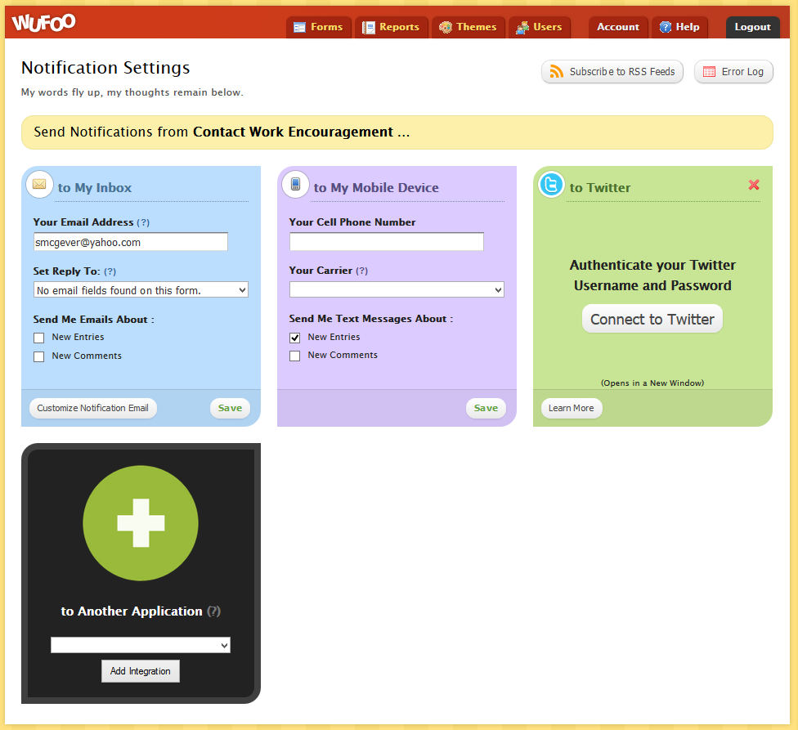
-On the Forms Manager page, click on “Notifications”. This will bring you to the page below, which will allow you to add “to Another Application” in which you will choose Twitter.

-After you do that, then edit the message which Wufoo will send to Twitter. This message will end up going out as a text message to leaders on the team. I think it is also important to include a link back to the form. In order to make the link smaller I used the Google link shortener so the link will fit better (go here to make one http://goo.gl/) Ours says this:
Woohoo! {entry:Field4} from {entry:Field5} did contact work! Update yours here http://goo.gl/hbNiFm

Step 4 - Create a Celly Account and Use the “Receptor” Feature
-Create an account on cel.ly
-Create a new “Cell”
-In the welcome message say something like this...
You joined the PVYL Contact Work Group! Update here https://pvyl.wufoo.com/forms/contact-work-encouragement/
-Then scroll down and look at the bottom right where you will see information about “Receptors”. What this will do is monitor your Twitter feed and when any tweet comes through, it will automatically text message everyone in your group the information in the tweet. In your case, the update you put together in Wufoo.
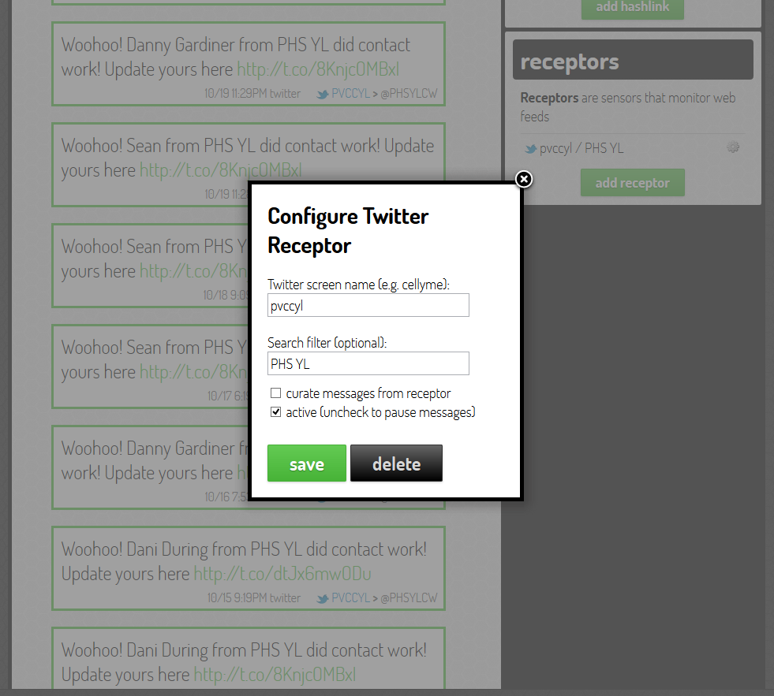
-In my case we have several clubs in the area, so I created a separate “cell” for each club so leaders will only get a text about contact work from their own club. In order to achieve this I used the “Search filter” feature to “look” for the school name that was provided in the dropdown option in our Wufoo form. This way only tweets with that information will go to this group... effectively only texts from leaders on that team.

Step 5 - Add leaders to the Celly group.
That is it!
Step 6 (Optional) - View the reports
You can use Wufoo to view reports of leaders and schools if needed. We use it for prizes at monthly leadership meetings and interview the top people for their tips and advice.
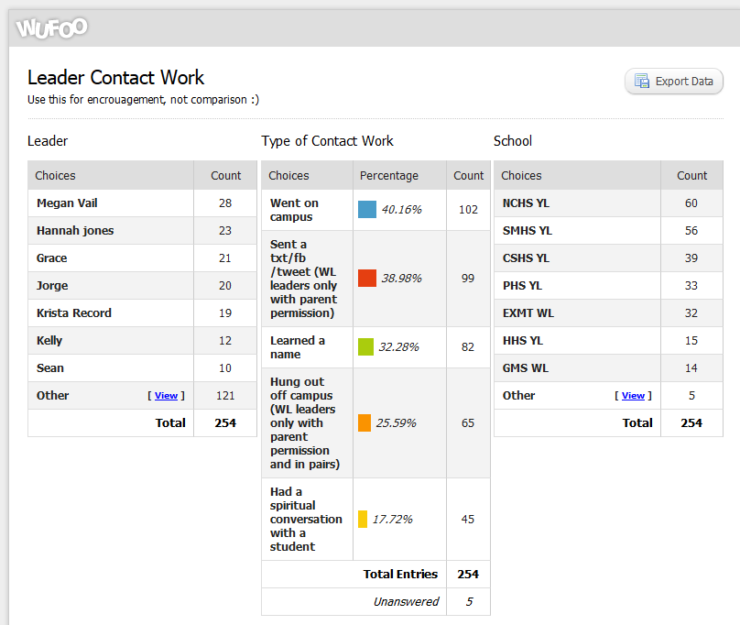

The end product will look like this...
