Leading At Summer Camp

Trust in Christ and listen to Him every single moment (John 15:5)

Overview
- Pray often.
- Grab a short quiet time and listen every day.
- Look for what God has in store for you - He is at work in you too!
- Realize that you are in a spiritual struggle. You have an enemy.
- Use your free time wisely. This may mean doing things you don’t want to do.
- Be yourself, yet live for the Lord and the kids with you (shower, attitude, etc.).
- Be honest and vulnerable. Our job is not to impress them with our life and faith, but to show Christ.
- Ask lots of questions about family, interests, hopes, past, life, etc. Listen.
- Camp is a two week commitment, the week there and the week following up.
- Make sure every kid clearly knows the gospel. Make sure that every kid has the chance to respond and that you know what they are thinking, how they are feeling, where they are in a decision to follow Christ.

Packing

All the normal stuff

- Waaaayyyyy more T-shirts and socks than you think you need!!!
- Jeans
- Shorts
- A light jacket or sweatshirt
- Camera
- Tennis Shoes
- Sandals
- Swimsuit (leaders set a modest tone)
- Sunscreen
- A beach & bath towel
- Bug Spray
- One Dressier outfit
- 2 sets of clothes that you can thrash and throw away
- Cabin matching outfit
- It will be cold some of the time at camp so bring some warm clothes!

PLUS…
- Bandannas
- Extension cord
- Pens, paper
- A beach towel
- Cabin time snacks
- Plastic bag for wet clothes
- Alarm clock
- Aspirin
- An iron?
- A mirror
- Flashlight
- Extra batteries
- Extra toothbrush
- Extra soap
- Extra towels

For Tableau and Team Games…

- Bandannas
- Cowboy hats
- Any wild hats
- Dollar store kids cowboy stuff
- Matching outfits
- Duct tape
- Body paint or markers

The Bus
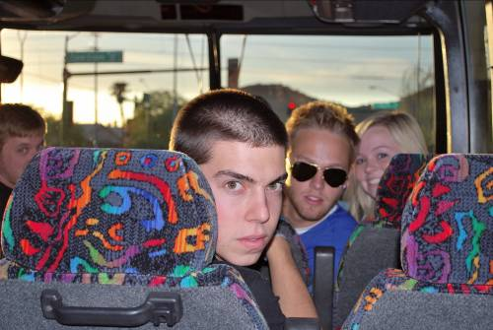Camp starts when we show up to get on the bus. You get to serve, be inclusive, learn names, meet parents… treat it like the first event of camp.

- Greet the parents, introduce yourself
- Learn names
- Load their, your luggage
- Take the worst seat, take a strategic seat
- Bring a VCR/DVD movie (animated are best)
- Group games
- Magazines w/ quizzes
- Trivia games
- Brainteasers
- Video bingo

- Sit and get to know a kid ask about family especially, interests, hopes, past life

The Camp
The camp is set up to have you lead your kids, and lead them to Christ. There will be speaker, funny guys called program, high school kids working hard called Work Crew, college kids running things which is called Summer Staff, people whose whole job it is to just help us called Head Leaders. But the camp is set up for YOU to LEAD.
Know your personality and what it will take to LEAD… how you start will set the stage.
- Busy then free time
- Don’t tell them the schedule
- Lead by example, spend energy that can only come from God
- We need to be more excited than they are
- Pull kids in that aren’t participating
- Make kids heroes, give them the limelight
- Laugh hard, play hard

Club

- 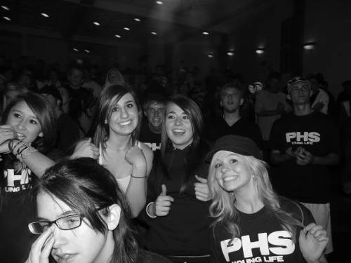Try to be first in line so you can get them in the front, especially for the first club.
- Sing loud, sing crazy, it has nothing to do with your voice
- Dance like a maniac
- Keep your group somewhat together
- Sit next to the most needy kid (whether he’s quiet or the center of attention)
- Pray for your kids, especially during the talk
- Don’t let them lay down … laying down = tuning out
- Don’t let them talk during the message. Stop it before the message.

MEals

- 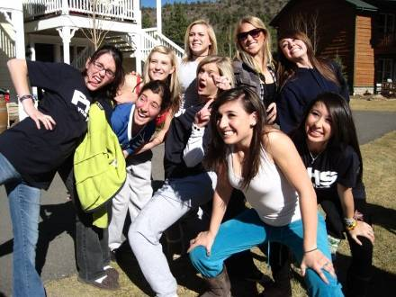Leaders take the worst seats
- Leaders take the last helping
- Welcome other kids warmly
- Include all kids in conversation
- Be at meals 10 minutes early to grab tables
- Know all their names
- This might be their first real family meal
- Don’t start or encourage the annoying chants, if you do – do it on the last day
- YOU are the leader

Discipline

- When choosing between friendship and respect, choose respect
- YOU are the leader, you make the decision what is best for them
- Don’t allow sneaking out (schedule a Head Leader “Bust”)
- Don’t allow practical jokes
- Don’t let kids talk or sleep in club
- Don’t tell kids the schedule
- Be at everything, including breakfast
- Go to bed, lights out, wear them out…
- Guys to guys – girls to girls leaders too… hugs … cabin stuff… don’t hit on summer staff

Free Time = Leading Time and one-on-ones
- 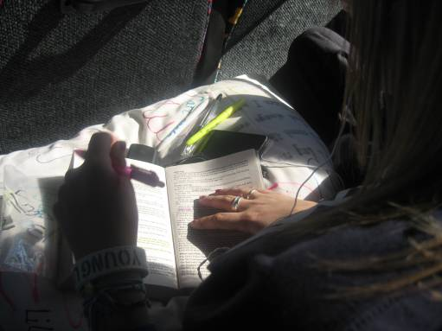Plan it … “let’s all play Frisbee golf, let’s go to the Whistle Stop, etc.”
- Clean your area in the cabin, kids will hang out there

Tell them in the first cabin time you want to meet with them individually
Have a plan, goal and key questions for each kid
Ideas…
  - How is your time here different from what you were expecting?
  - How are you tracking with the speaker?
  - What are you giving your life to?
  - Where in your life do you feel the most stress? Why?
  - Describe your relationship with your parents
  - How would you describe sin? What effects of it do you see in your life? Why did Jesus have to die?
  - Who has had the greatest impact on your life so far?
  - If you could change one thing about your life, what would it be?
  - If you could erase one memory from the past, what would it be?
  - How is life different here than at home?
  - Would you consider yourself a Christian? Why?
- Be bold, they are expecting you to be (it is OK to ask hard questions!)

Leading a Person to Christ and follow-up

- One verse evangelism: Rom 6:23
- “Compared to what sin and everything life has to offer you, following Christ is BETTER (BTR… Belief. Trust. Repentance.) Acts 13:38, Rom 9:30, Acts 2:37
- Pray with them.
- Have them tell someone at camp
- Tell them about Say-So and New Christian walk
- Make a plan for home
- Call within 24 hours of being home
- Campaigners
- Church (ideally leading to baptism in church Mt 28:19-20)

Cabin Time

We are not professional counselors; we are people who know The Counselor (John 16:7-8)

Your role
Main goals for each night:
1. (Intro) Everyone talks
2. (Sin) That they know what sin is, what it’s consequences are and that they have it.
3. (Cross) What is your response for what Christ did?
3. (Resurrection / Appropriation) Where do you stand with Christ?

- Create a safe place
- You are not the Holy Spirit
- You communicate info, understanding plus passion … not forcing faith or conviction

Practical stuff (Especially 1st Cabin Time)
- Set and enforce ground rules
  - Sit in a circle on the floor (no lying down)
  - Confidentiality (unless someone is in danger)
  - Only one person talks at a time
1st Ask them about the content of the talk (What did he/she talk about?)
2nd Ask them about their feelings (How did you feel when he/she said…)
  - Respect, don’t make fun
  - Open ended questions
  - Close in prayer
***(Be VERY careful not to discuss what is said in front of any campers)

Questions
What if?
- They don’t settle down?
- They interrupt each other, or some kids dominate the discussion?
- They are falling asleep?
- I have some campaigner kids?
- Kids ask tough questions?

- Open the discussion (sometimes a transition is needed to focus, a real easy questions, or a brief prayer)
- Ask quality questions, clarifying questions

  - Repeat what they said in your own words
  - Ask kids to tell you more
  - Identify the feelings behind the words

- Draw everyone into the discussion

  - Affirm kids constantly
  - Model vulnerability
  - Answer questions with questions
  - Draw out silent types, tone down talkers
  - Recruit the help of Christians beforehand

- Listen twice as much as we speak

